

REPUBLIC OF YEMEN SANA’A UNIVERSITY FACULTY OF ENGINEERING
MECHATRONICS ENGINEERING DEPARTMENT

3D Printer Project
Prepared by:
Abdulmalik Al-qupati. (202274051)

Hamzah Al-amrani. (202274100) Jabr Saleh Al-qarafee(202274275) Mohammed Al-harbi. (202274099)

Supervised by:
Eng : Ryan Al-ghusaimi

Abstract:

A 3D printer is an innovative and revolutionary technology that allows for the creation of three-dimensional objects by layering materials based on a digital design.
It is also known as additive manufacturing. The concept of 3D printing has gained significant attention and popularity in recent years due to its wide range of applications and transformative potential in various industries.
This technology allows for the creation of three-dimensional objects by adding material layer by layer based on a digital design.
The advantages of 3D printing include design freedom, customization, reduced material waste, cost-effectiveness for small-scale production, and shortened development cycles.
A wide range of materials can be used in 3D printing, including plastics, metals, ceramics, composites, and even biological materials. This versatility allows for the production of complex and functional parts with specific properties.

Table of Contents
Introduction 1
Components 3
Software and Firmware 13
Discussion 15
Obstacles and Mistakes 17
Results 18
Conclusion 20
References 21

Introduction
The 3D Printer Project is an innovative and exciting endeavor that aims to explore the capabilities and potential applications of 3D printing technology. 3D printing, also known as additive manufacturing, is a revolutionary process that allows the creation of three-dimensional objects by layering materials based on a digital design. This project will delve into the various aspects of 3D printing, including its history, working principles, materials, applications, and future prospects.

- History of 3D Printing:
The history of 3D printing dates back to the 1980s when the technology was initially developed for rapid prototyping in the manufacturing industry. Over time, advancements in technology and falling costs made 3D printers more accessible to a wider audience, leading to its adoption in various fields, including aerospace, healthcare, automotive, and consumer goods.

- Working Principles of 3D Printing:
The fundamental principle of 3D printing involves the creation of objects layer by layer. It starts with a digital design that is converted into a format readable by the 3D printer. The printer then follows this design and deposits or solidifies material layer by layer to build the desired object.

- Future Prospects:
The future of 3D printing holds tremendous potential. As the technology continues to evolve, we can expect advancements in printing speed, resolution, and the range of printable materials. Industries will benefit from reduced costs, increased customization, and improved supply chain efficiency. Moreover, 3D printing may contribute to sustainable manufacturing practices by minimizing material waste and energy consumption.

Advantages

Complex Structures and Shapes
Traditional manufacturing methods depends on cutting and molding technologies to create a limited number of structures and shapes, with more intricate hollow ones having to be formed from a number of parts and assembled together. However, 3D printing process can create any product having different shapes and sizes without creating any problem. Figure below shows the Figures: Complex 3D printed parts


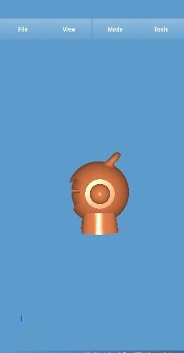

Less waste
During manufacturing process, large number of raw materials keeps on going wastage. It does not seem much effect on beginning but at the end, collection of wastage creates loss in amount. So, minimizing the waste is one of the essential steps that need to be carried out for proper and large production of the goods. 3D printing process eliminates the waste to the minimal amount. Only required number of materials are used for the manufacturing process.

Cheap Manufacturing
3D printing helps companies save up to 70 percent of their manufacturing cost. This is attained through lower packaging and shipping costs related to more reliable and cheaper raw material sand lesser workforce needed, as well as overseas parts suppliers. In the end, this technology makes progressive companies more profitable.

Better Quality
Avoiding most of the mass manufacturing faults does not only make better products but it also extends their life as they will break less often. This is not necessarily a great benefit for manufacturers who need the product life cycle to be profitable, but it is certainly a major benefit for the end consumer.

Components

RAMPS 1.4 Board:
The RAMPS (RepRap Arduino Mega Pololu Shield) 1.4 board is an open-source electronics board widely used in 3D printers. It acts as an interface between the Arduino Mega and various components of the printer. The RAMPS board provides connections for stepper motors, hotend, heated bed, endstops, and other peripherals. It allows for efficient control and communication between the printer's hardware and firmware.

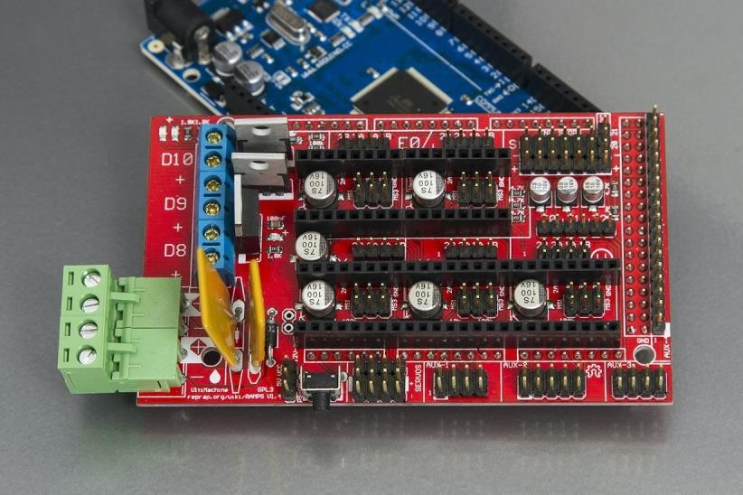
Figure : Ramps 1.4

Arduino Mega:
The Arduino Mega is a powerful microcontroller board that serves as the brain of the 3D printer. It runs the firmware responsible for interpreting G-code commands and controlling the printer's movements and operations. The Arduino Mega communicates with the RAMPS board to send signals to the stepper motors, read temperature sensors, and monitor the status of endstops.
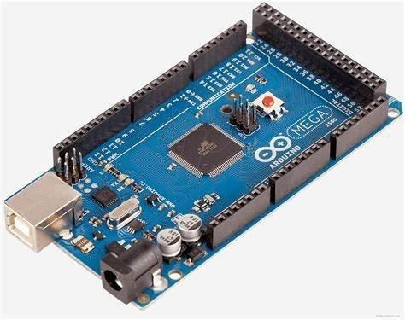
Figure : Arduino Mega

Stepper Motors:
Stepper motors are essential for precise control of the printer's movements. They are used to drive the axes (X, Y, and Z) as well as the extruder. Stepper motors provide accurate positioning by dividing a full rotation into steps. The RAMPS board drives these motors by sending specific electrical pulses, allowing for controlled and incremental movement.
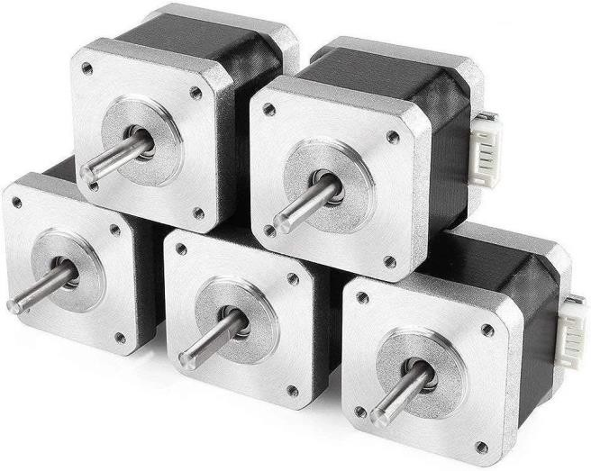
Figure : Stepper Motors

Extruder:
The extruder is responsible for feeding the filament into the hotend, where it is melted and extruded layer by layer to build the 3D object. It consists of a stepper motor that drives a gear mechanism to push the filament into the hotend. The extruder also includes a heating element to melt the filament and a temperature sensor to maintain the desired temperature.
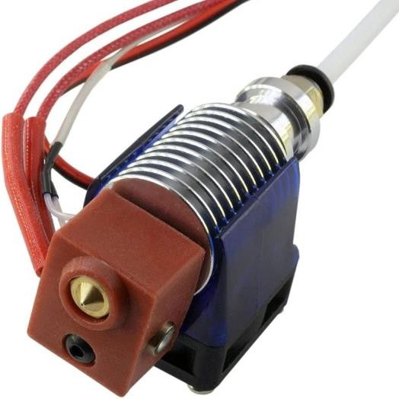
Figure: Extruder

Hotend:
The hotend is the component where the filament is melted and extruded. It typically consists of a heating block, a nozzle, and a temperature sensor. The heating block contains a heating element that raises the temperature of the block and nozzle to melt the filament. The temperature sensor, usually a thermistor or thermocouple, provides feedback to the firmware to ensure precise temperature control during the printing process.

Heated Bed:
The heated bed plays a crucial role in ensuring proper adhesion of the printed object to the build surface. It is typically made of a heat-conductive material with an integrated heating element. The heated bed is controlled by the RAMPS board and maintains a specific temperature, usually between 40 to 60 degrees Celsius, to prevent warping and improve print quality.

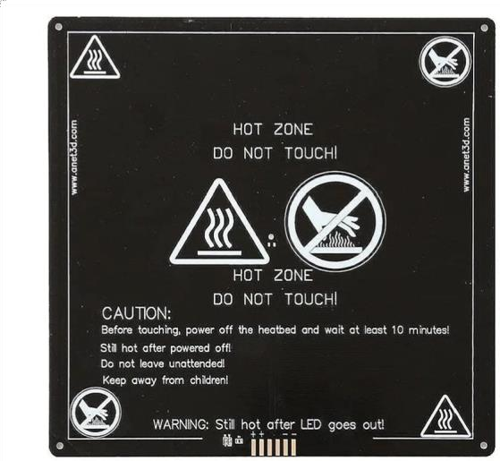

Endstops:
Figure : Heated Bed

End stops are mechanical or optical switches that serve as the printer's limit switches. They are strategically placed at the end points of each axis to determine the printer's home position and provide reference points for accurate movements. The endstops help prevent the printer from moving beyond its physical constraints, ensuring safe and reliable operation.
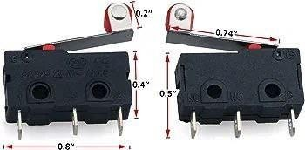
Figure : End Stop

Power Supply:
A suitable power supply is required to provide the necessary voltage and current to the various components of the 3D printer. The power supply typically converts AC power from an outlet into DC power suitable for the printer's operation. It powers the Arduino Mega, RAMPS board, stepper motors, hotend, heated bed, and other electronic components.

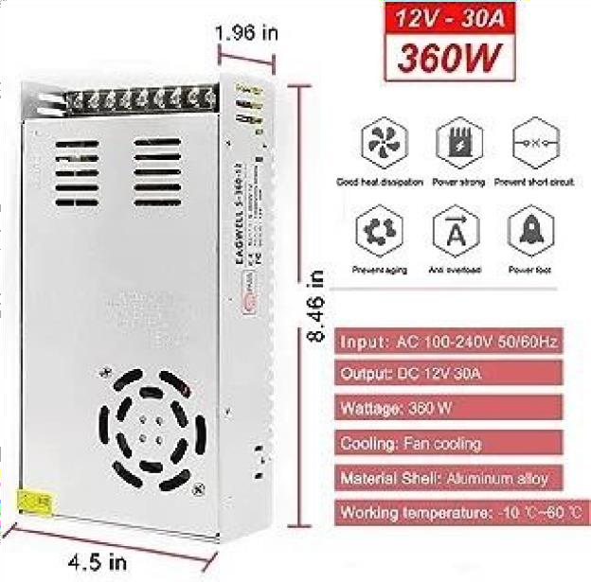
Figure : Power supply (12V)

LCD Display:
An LCD display with a control interface is often included in 3D printers for easy user interaction and control. The display allows users to navigate through menus, adjust settings, monitor print progress, and display important information such as temperatures and print status. The control interface, commonly consisting of a rotary encoder and buttons, enables users to make selections and navigate the printer's menu system.
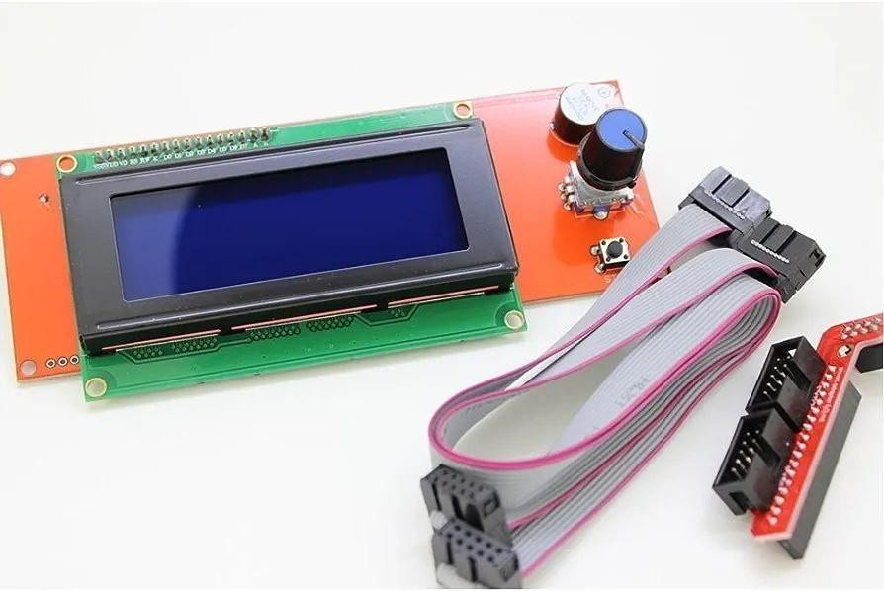
Figure : LCD Screen

Cooling Fans:
Cooling fans are crucial for maintaining optimal temperatures in different parts of the printer. They help dissipate heat generated by the hotend, electronics, and other components. The cooling fans ensure that the hotend stays at the desired temperature and prevent overheating of the electronics, ensuring stable operation and preventing potential damage.
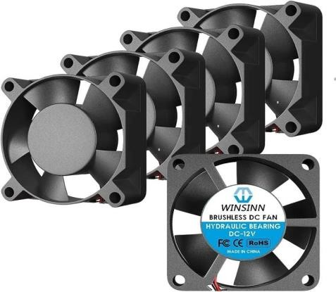
Figure : Fans

Bearings:

Bearings are used in various parts of the 3D printer to reduce friction and enable smooth movement. They are commonly employed in the linear guides and pulleys. Linear bearings ensure smooth and precise motion of the print head along the X, Y, and Z axes, while pulley bearings allow smooth movement of the belts that drive the printer's motion. Bearings contribute to the overall accuracy and reliability of the printer.
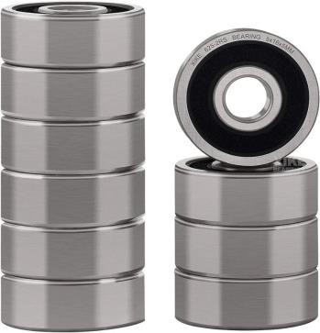
Figure: Bearings

Gears:

Gears may be used in the mechanical system of the printer to transmit power and torque from the stepper motors to the axes. Gears allow for speed reduction or amplification, depending on the configuration, to achieve the desired motion and accuracy. They are commonly found in the extruder mechanism and other parts of the printer where torque or rotational force needs to be transferred efficiently.

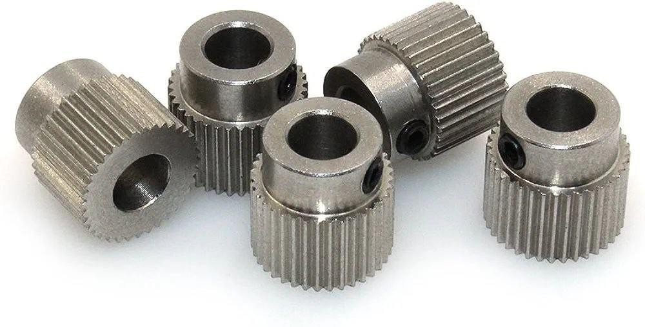
Figure: Gears (Filament Gear)

Rods:
There are two types of rods commonly used in 3D printers: threaded rods and smooth rods. Threaded rods are typically used for the Z-axis to provide precise vertical movement. The threaded rods are connected to the stepper motor and, as the motor rotatesthe rods, they cause the print head to move up or down. Smooth rods, on the other hand, are used for the X and Y axes to provide smooth linear motion. The print head and build platform glide along these smooth rods with the help of bearings, ensuring precise and smooth movement during printing.
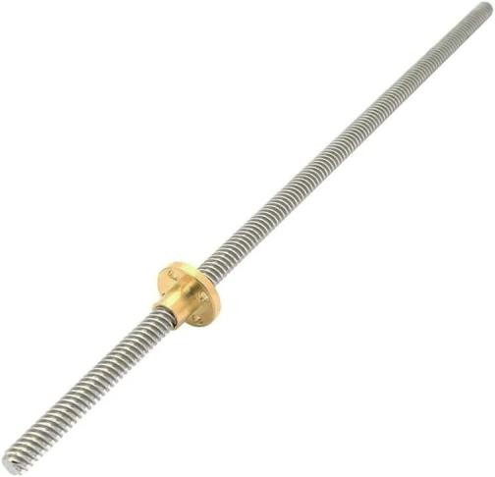
Figure: threaded rod

Wiring and Connectors:
Wiring and connectors are crucial for establishing proper electrical connections and signal transmission between the various components of the 3D printer. They ensure that power, data, and control signals are correctly routed and delivered to the respective components. Different types of connectors, such as crimp connectors and terminal blocks, are used to securely connect wires and facilitate easy assembly and maintenance of the printer.
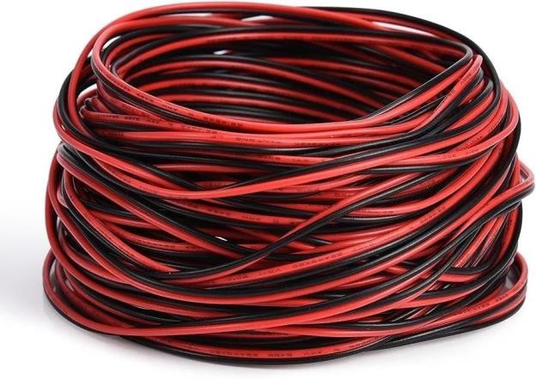
Figure : Wires

Frame and Mechanics:
The frame and mechanical components provide the physical structure and stability for the 3D printer. The frame supports and holds all the components in place, ensuring rigidity and accuracy during printing. Linear guides, belts, pulleys, and other mechanical elements contribute to controlled and precise movement of the print head and build platform. A sturdy and well-designed frame is crucial for achieving high-quality prints and minimizing vibrations or wobbling during operation.
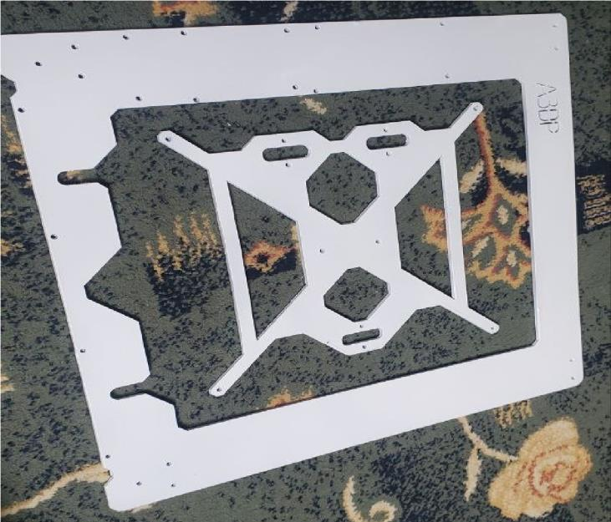
Figure 16: Frame

Methodology

Planning and Research:
The first step involved conducting thorough research and planning. This included understanding the basic principles of 3D printing, exploring different printer designs, and determining the desired specifications and features for the printer. It also involved researching the components required, such as the RAMPS 1.4 board, Arduino Mega, stepper motors, hotend, heated bed, and other essential parts.

Design Selection:
Based on the research, a suitable design was selected for the 3D printer. Factors such as the printer's size, print volume, construction materials, and mechanical configuration were considered. The chosen design aligned with the project requirements and provided a solid foundation for the build.

Component Acquisition:
Once the design was finalized, the necessary components were procured. This involved sourcing the RAMPS 1.4 board, Arduino Mega, stepper motors, extruder, hotend, heated bed, endstops, power supply, LCD display, cooling fans, bearings, gears, rods, wiring, connectors, and other required parts. Care was taken to ensure the compatibility and quality of the components.

Assembly:
The assembly process involved carefully following the manufacturer's instructions and design specifications to build the printer. The frame components were assembled, and the linear guides, smooth rods, and threaded rods were installed according to the design requirements. The RAMPS 1.4 board was connected to the Arduino Mega, and the wiring was routed and connected between the various components, ensuring proper electrical connections and signal transmission.

Calibration and Firmware Setup:
After the physical assembly, the printer required calibration and firmware setup. This involved configuring the firmware settings, such as motor steps per revolution, acceleration, and maximum feed rates, to ensure accurate movements. The endstops were correctly positioned and calibrated to establish the printer's home position and limit switches. Temperature calibration for the hotend and heated bed was performed to achieve precise control.

Testing and Troubleshooting:
Once the printer was assembled and calibrated, it underwent testing and troubleshooting. Various test prints were conducted to verify the printer's functionality and performance. Issues, such as misalignment, backlash, or inconsistent extrusion, were identified and addressed. The printer's movements, temperature control, and overall print quality were thoroughly assessed and optimized.

Documentation:
Throughout the build process, detailed documentation was maintained, including component specifications, assembly steps, calibration settings, and any modifications or adjustments made. This documentation serves as a reference for future maintenance, troubleshooting, or upgrades and can be included in the final report.

Finalization and Evaluation:
Once the printer was fully functional and producing satisfactory prints, a final evaluation was conducted. The printer's performance, reliability, and print quality were assessed against the initial project requirements. Any additional improvements or refinements were made to ensure optimal operation.

Software and Firmware
When selecting a firmware for our 3D printer project, we had several options to choose from. Various firmware solutions are available for 3D printers, each with its own unique features and advantages. After careful consideration, we decided to utilize the Marlin firmware due to many reasons such as its open source nature and its compatibility with Ramps 1.4 board.
Marlin firmware is an open-source firmware specifically designed for 3D printers. It serves as the software interface between the printer's hardware and the user's commands. In our 3D printer project, we utilized the Marlin firmware to control and coordinate the various components, such as the RAMPS 1.4 board, Arduino Mega, stepper motors, extruder, hotend, heated bed, endstops, and more. Here is a detailed explanation of Marlin firmware and the required calibrations we performed:

Features of Marlin Firmware:
Marlin firmware offers a wide range of features and functionalities that are essential for 3D printing. Some key features include:
G-code Interpreter: Marlin firmware interprets G-code commands, which are instructions in a standardized language that define the movements, temperatures, and other parameters for the printer.
Motion Control: Marlin provides precise control over the printer's movements. It calculates the required steps for each axis based on the desired position and speed, ensuring accurate and smooth motion.
Temperature Control: Marlin firmware implements PID (Proportional Integral
Derivative) control algorithms to regulate the temperature of the hotend and heated bed. It continuously monitors the temperature readings from the sensors and adjusts the heating elements accordingly.
Endstop and Homing Control: Marlin firmware supports the use of endstops for homing and limit detection. It allows for the calibration of the printer's home position and ensures that the printer does not move beyond its physical limits.
LCD and User Interface: Marlin firmware enables communication with an LCD display and control interface. This allows users to navigate menus, adjust settings, monitor print progress, and interact with the printer easily.

- Firmware Configuration:
Before uploading the Marlin firmware to the Arduino Mega, it requires configuration to match the specific hardware and printer setup. This involves modifying the configuration files provided with the Marlin firmware package. The configuration files contain settings related to the printer's hardware, such as motor steps per revolution, maximum feed rates, acceleration values, thermistor types, and other parameters. By correctly configuring these settings, the firmware can interface effectively with the printer's components.

Motor Steps Per Revolution:
One critical calibration step is determining the accurate motor steps per revolution for each axis. This ensures that the printer moves the correct distance when commanded. The motor steps per revolution setting depends on the type of stepper motor and the mechanical configuration of the printer. To calibrate this, a test pattern or known distance is printed, and the actual distance is measured. The motor steps per revolution value is then adjusted until the printer moves precisely as expected.

Endstop Calibration:
End stops provide reference points for the printer's movements and help establish the home position accurately. Calibration involves positioning the endstops correctly along the axes and configuring the firmware to recognize their positions. This ensures that the printer homes accurately and prevents any collisions or incorrect positioning.

Temperature Calibration:
Marlin firmware allows for temperature calibration of the hotend and heated bed to achieve accurate temperature readings. This is important for consistent extrusion and proper adhesion of prints. Calibration involves comparing the firmware-reported temperature with a calibrated thermometer or thermocouple. Adjustments are made in the firmware to match the actual temperature accurately.

PID Tuning:
To achieve stable and precise temperature control, PID tuning is performed. This involves adjusting the PID parameters (Proportional, Integral, and Derivative) in the firmware to minimize temperature fluctuations and maintain a consistent temperature. PID tuning helps prevent issues such as overheating, temperature oscillations, or underheating of the hotend and heated bed.

Extruder Calibration:
Extruder calibration ensures accurate filament extrusion. It involves measuring the actual amount of filament extruded compared to the expected value. By adjusting the extruder steps per unit (e.g., mm) setting in the firmware, the extruder can accurately push the desired amount of filament.

Print Bed Leveling:
Bed leveling is a crucial calibration step to ensure the print bed is parallel to the printer's nozzle. Marlin firmware supports various bed leveling methods, such as manual or automatic leveling with the help of multiple probing points. Bed leveling compensates for any variations or unevenness in the print bed, resulting in improved print quality and proper adhesion.

By performing these calibrations and configuring the Marlin firmware correctly, we ensured that our 3D printer operated reliably and produced accurate and high-quality prints. The calibrations allowed us to fine-tune the printer's movements, temperature control, extrusion, and bed leveling, resulting in optimal performance and consistent results.
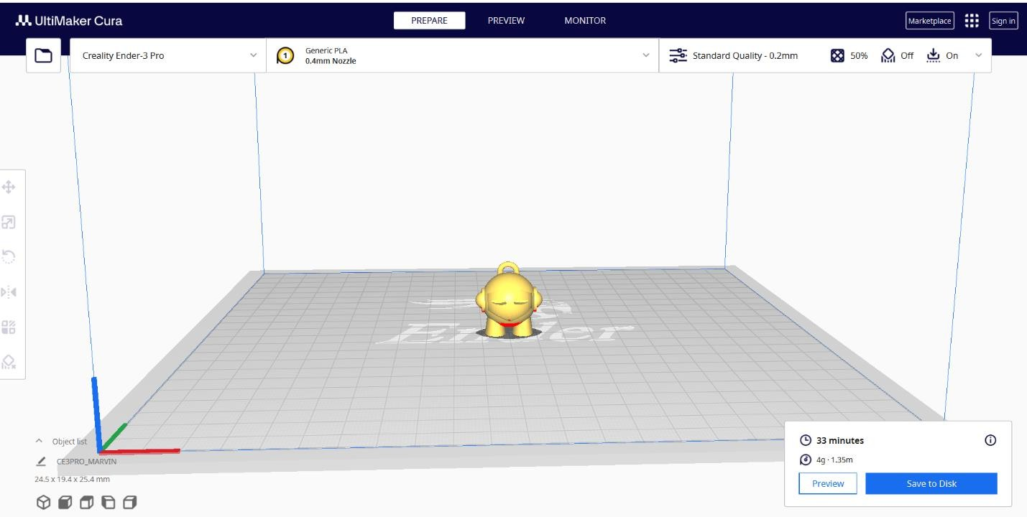
Figure: Cura Software

Discussion
The results of our 3D printer project were highly satisfactory, as we successfully built a functional and reliable machine capable of producing high-quality prints. Through careful planning, diligent research, and troubleshooting, we were able to overcome challenges and achieve our desired outcomes. Let's discuss the benefits of this project and explore any possible deviations.

Cost Savings:
One of the significant benefits of building our 3D printer was cost savings. By assembling the printer ourselves and utilizing open-source firmware like Marlin, we avoided the higher price tags associated with pre-built printers. This allowed us to allocate our budget towards high-quality components and upgrades, ultimately resulting in a printer that offered excellent value for money.

Customization and Flexibility:
Building our own 3D printer provided us with the opportunity to customize and tailor the machine to our specific needs. We could select and integrate components that matched our desired specifications, ensuring optimal performance and functionality. The flexibility to modify firmware settings and experiment with different filament types and printing parameters further enhanced the versatility of our printer.

Learning Experience:
This project served as an invaluable learning experience. We gained a deep understanding of the inner workings of 3D printers, including the hardware components, firmware configurations, and troubleshooting techniques. Through hands-on assembly and problem-solving, we acquired practical skills and knowledge that can be applied to future projects or even professional endeavors.

Creative Freedom:
Having our own 3D printer offered us the freedom to explore and unleash our creativity. With the ability to design and print our own prototypes, models, and functional objects, we could bring our ideas to life quickly and efficiently. This creative freedom opened up possibilities for rapid iteration and experimentation, enabling us to refine our designs and concepts with ease.

Community Engagement and Collaboration:
Building a 3D printer exposed us to a vibrant and supportive community of 3D printing enthusiasts. We had the opportunity to engage with like-minded individuals, exchange ideas, and seek guidance. This community aspect fostered collaboration, enabling us to learn from others' experiences, share our own insights, and contribute to the collective knowledge of the DIY 3D printing community.While our project yielded successful results, it's essential to acknowledge possible deviations that could occur. Some deviations include:

Calibration Challenges:
Achieving precise calibration and fine-tuning of the printer can be time-consuming and require patience. Deviations in calibration could result in print quality issues, inconsistent layer heights, or poor adhesion. Regular maintenance and calibration checks are necessary to ensure optimal performance.

Hardware Limitations:
Depending on the components chosen, there may be limitations in terms of print volume, print speed, or compatibility with certain materials. These hardware limitations could restrict the scope of projects and designs that can be executed on the printer.

Firmware Updates and Compatibility:
Over time, firmware updates may introduce changes or features that require adjustments to the printer's configuration. Staying up to date with firmware updates and ensuring compatibility with hardware components can be a continuous process. Deviations in firmware compatibility could lead to unexpected behavior or decreased functionality.

Time and Effort Investment:
Building a 3D printer requires a significant investment of time and effort. Deviations in project timelines or unexpected challenges could prolong the assembly and calibration process. It's important to allocate sufficient time and resources to complete the project successfully.Despite these possible deviations, the benefits and rewards of building our own 3D printer outweigh the challenges. The ability to create customized prints, the cost savings, the learning experience, and the engagement with the 3D printing community make this project highly worthwhile.

Obstacles and Mistakes
During the course of our 3D printer project, we encountered several challenges and made a few mistakes. However, through troubleshooting and problem-solving, we were able to overcome these issues and achieve successful results. Here is a discussion highlighting some of the mistakes we encountered and how we managed to resolve them:

1.Z-Axis Calibration:
One of the initial challenges we faced was calibrating the Z-axis correctly. We noticed that the first layer of prints was either too squished or too loose, resulting in poor adhesion and print quality. After some investigation, we realized that our Z-axis steps per millimeter value in the firmware was incorrect. This calibration setting determines the precise movement of the Z-axis. We recalibrated this value by measuring the actual distance the Z-axis moved compared to the commanded movement and adjusted the steps per millimeter value accordingly. This resolved the issue, and we obtained accurate layer heights and improved bed adhesion.

Extruder Skipping Steps:
Another issue we encountered was the extruder skipping steps during filament extrusion. This resulted in inconsistent extrusion, under-extrusion, and the print failing to complete. After examining the problem, we determined that the extruder motor was not receiving sufficient current. We adjusted the motor current by modifying the relevant settings in the firmware. Additionally, we checked for any obstructions in the filament path, cleaned the drive gear, and ensured proper tension on the filament. These steps helped alleviate the skipping issue, resulting in consistent and reliable extrusion.

Warping and Bed Leveling:
We faced challenges with warping and bed adhesion, leading to prints detaching from the print bed or warping during the printing process. This issue was primarily caused by uneven bed leveling. We addressed this by performing manual bed leveling and implementing mesh bed leveling with Marlin firmware. Manual bed leveling involved adjusting the bed's leveling screws to ensure an even and parallel surface. Mesh bed leveling allowed us to compensate for any irregularities in the bed by probing multiple points and generating a mesh map. By applying these techniques, we achieved a leveled print bed and improved adhesion, reducing warping and detachment issues.

Temperature Fluctuations:
Temperature fluctuations in the hotend and heated bed can negatively impact print quality and consistency. We initially experienced temperature swings that affected extrusion and resulted in inconsistent layers. To address this, we performed PID tuning for both the hotend and heated bed. By adjusting the PID parameters in the firmware, we achieved stable and accurate temperature control. This significantly reduced temperature fluctuations, resulting in improved print quality and layer adhesion.

Firmware Configuration Errors:
During the initial stages, we encountered issues related to incorrect firmware configuration. These errors caused the printer's movements to be inaccurate, resulting in skewed prints. We carefully reviewed and cross-checked the firmware configuration files, ensuring that the settings matched our printer's specific hardware and mechanical setup. By rectifying these configuration errors, we achieved precise and accurate movements, resulting in properly aligned prints.

Overall, these mistakes and challenges taught us valuable lessons in troubleshooting and problem-solving. Through careful analysis, research, and experimentation, we were able to identify the root causes of the issues and implement effective solutions. By continuously learning from our mistakes and adapting our approach, we were able to optimize our 3D printer's performance, resulting in consistent and high-quality prints.

Results

Successful Construction:
The primary result of our 3D printer project was the successful construction of a functional and reliable printer. We meticulously assembled the printer by carefully integrating high- quality components and ensuring proper wiring and connectivity. The printer was built according to our planned specifications, meeting our desired size, capabilities, and features.

High-Quality Prints:
Our 3D printer consistently produced high-quality prints with excellent detail, accuracy, and surface finish. Through careful calibration and optimization of printing parameters, we achieved precise layer heights, minimal stringing, and well-adhered prints. The printer's reliable extrusion and accurate movement control contributed to the overall print quality.

Versatility and Flexibility:
The printer demonstrated versatility and flexibility in accommodating various filament types and designs. We successfully printed with different materials, including PLA, ABS, PETG, and flexible filaments, expanding the range of applications for our printer. Additionally, the printer supported intricate designs, complex geometries, and functional prototypes, showcasing its adaptability and versatility.

Customization and Upgradability:
The DIY nature of our 3D printer project allowed for customization and upgradability. We were able to modify firmware settings, hardware components, and mechanical configurations to suit our specific requirements. This customization provided the freedom to adapt the printer to future needs, enabling potential upgrades or enhancements to further improve its capabilities.

Learning and Skill Development:
The project served as a valuable learning experience, providing us with in-depth knowledge of 3D printing principles, troubleshooting techniques, and firmware configurations. We acquired hands-on skills related to assembling, calibrating, and operating a 3D printer. This knowledge and expertise can be applied to future projects and contribute to our overall technical proficiency.

Cost Savings:
By building our own 3D printer instead of purchasing a pre-built one, we realized significant cost savings. The DIY approach allowed us to allocate our budget to high- quality components, resulting in a printer that offered excellent value for money. The cost savings can be further maximized through the use of open-source firmware and materials.

Community Engagement:
Throughout the project, we actively engaged with the 3D printing community, contributing to forums, seeking advice, and sharing our experiences. This community engagement not only provided valuable insights and support but also fostered collaboration and knowledge sharing among fellow enthusiasts.

Conclusion
In conclusion, our 3D printer project was a resounding success, resulting in the construction of a functional and reliable printer capable of producing high-quality prints. Through careful planning, meticulous assembly, and troubleshooting, we overcame challenges and achieved our desired outcomes.

The project provided us with numerous benefits, including cost savings through the DIY approach andcustomization options to tailor the printer to our specific needs. The printer demonstrated versatility and flexibility in accommodating different filament types and complex designs, expanding its range of applications.

Moreover, the project served as an invaluable learning experience, enhancing our understanding of 3D printing principles, troubleshooting techniques, and firmware configurations. We acquired practical skills and knowledge that can be applied to future projects or professional endeavors.

The community engagement aspect of the project allowed us to actively participate in the 3D printing community, contributing to forums, seeking advice, and sharing our experiences. This collaboration not only provided valuable insights and support but also fostered a sense of camaraderie among fellow enthusiasts.

Overall, our 3D printer project showcased the benefits of building a printer from scratch, including cost savings, customization options, and the opportunity for continuous learning and skill development. The successful results, including the production of high-quality prints, validated our efforts and highlighted the effectiveness of our problem-solving and troubleshooting approaches.
Moving forward, we can leverage the knowledge and expertise gained from this project to further enhance and optimize our 3D printer's performance. The project serves as a foundation for future exploration and experimentation in the field of 3D printing, allowing us to unleash our creativity and bring our ideas to life with ease and precision.

References
  - Marlin Firmware: "Marlin Firmware." Available at: https://marlinfw.org/
  - Prusa Research: "Original Prusa i3 3D Printers." Available at: https://www.prusa3d.com/
  - RepRap: "RepRap Project." Available at: https://reprap.org/
  - MakerBot: "MakerBot 3D Printers." Available at: https://www.makerbot.com/ 5.OpenBuilds: "OpenBuilds 3D Printer Kits and Components." Available at:
https://openbuilds.com/
- Thingiverse: "Thingiverse - Digital Designs for Physical Objects." Available at:
https://www.thingiverse.com/
- 3D Hubs: "3D Printing Service | Order Custom 3D Prints Online." Available at:
https://www.3dhubs.com/
- Tinkercad: "Tinkercad | From Mind to Design in Minutes." Available at: https://www.tinkercad.com/
- Ultimaker: "Ultimaker 3D Printers." Available at: https://ultimaker.com/ 10.YouTube: Various 3D printing tutorial channels and resources available on YouTube.

